ID-ASD-PD
CENTRALIZED ACCESS DESK

VISUAL IMPAIRMENT

IDENTIFICATION OF THE CLIENT
LAST NAME: |  |  |  |  |  |  |  |  |  |  | FIRST NAME:
Date of birth: |  |  |  |  |  |  |  |  |  |  | Gender: |  |  |  |  | F M
Health insurance number: |  |  |  |  |  |  |  |  |  |  |  | Expiry:
Address: |  |  |  |  |  |  |  | City: |  |  |  |  |  |  |  |  | Postal code:
Telephone: | Home: |  |  |  |  |  | Cell: |  |  |  |  |  |  | Work: Ext.:
Email:
Mode of communication: Telephone TDD |  |  |  |  |  |  |  |  |  |  |  |  |  |  | Legislation: AHSSSYPA
APPLICANT
Professional’s name: |  |  |  |  |  |  |  |  |  |  |  |  | Professional’s number:
Telephone: |  |  |  |  |  |  |  |  |  |  |  |  | Fax:
Signature: |  |  |  |  |  | Date: |  |  |  |  |  |  | MD OD Date:
EYE HEALTH
Date of last eye exam:
Diagnosis OD
OS
Electrophysiological test results:

Date of onset of visual impairment:
Prognosis:

Refraction OD:
OS:
 |  |  |  |  | OD |  |  |  | OS |  |  |  |  |  |  |  |  | OU
Visual acuity (6 m)
With ophthalmological correction
Intraocular pressure

PERIPHERAL FIELD OF VISION
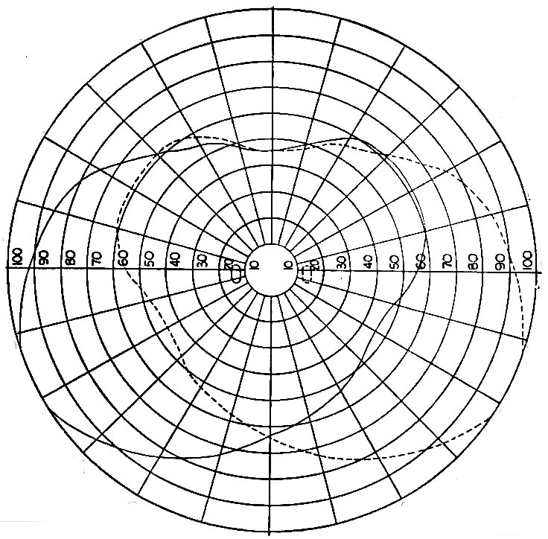 | 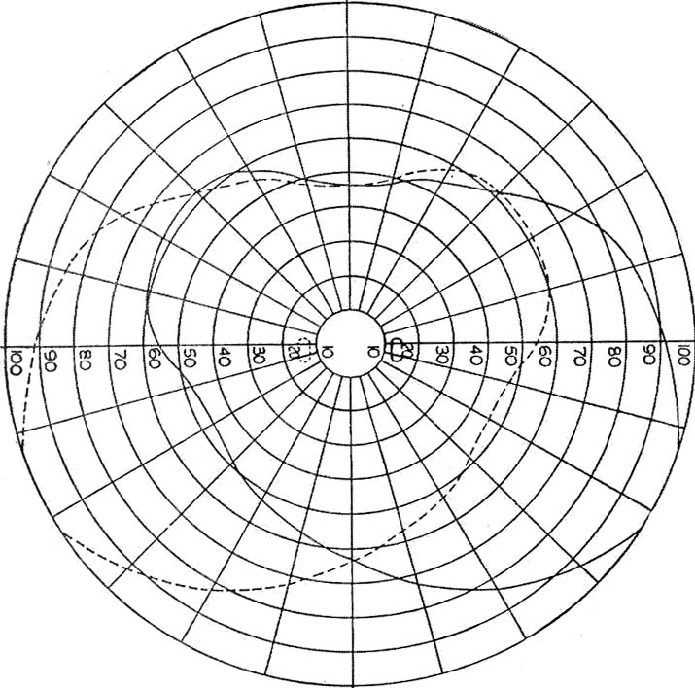
Target:

RETURN THE FORM TO THE ID-ASD-PD CENTRALIZED ACCESS DESK
By mail: 1180, boulevard Manseau, Joliette (Québec), J6E 3G8
By fax: 450-756-2898
By email: guichet.ditsadp.cissslan@ssss.gouv.qc.ca
For information: 1-877-322-2898

